Supplementary materials
Supplementary Figure
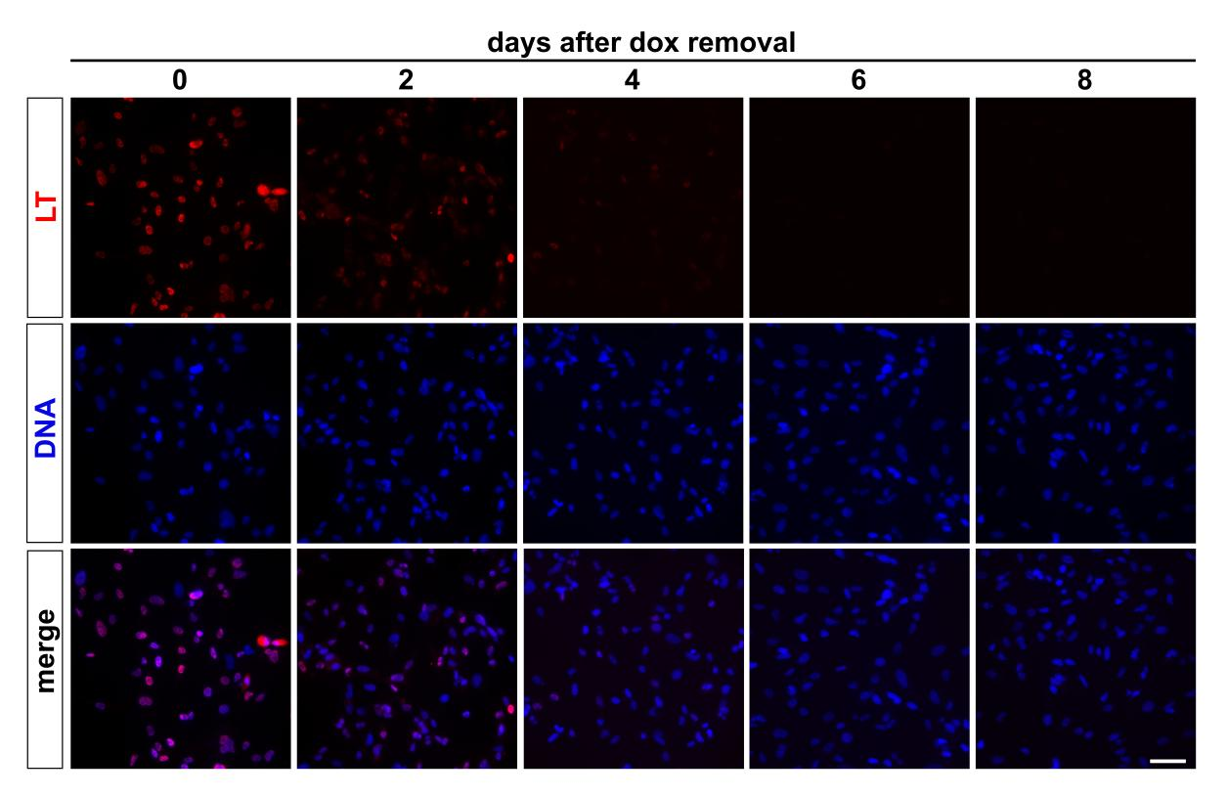

Supplementary Fig. 1. Immunofluorescent staining of LT expression in iCFB cultures.
Representative immunofluorescence images showing LT expression in iCFBs before dox withdrawal (day 0) and at 2, 4, 6, and 8 days after dox removal. Nuclei were counterstained with Hoechst 33342 (blue). Scale bar, 10 μm. LT, SV40 large T antigen; dox, doxycycline.

